LAMBTON COLLEGE



**A Report on**

[**Lab 4,5,6 on AWS Cloud Foundations]**

121 Brunel Rd, Mississauga

ON L4Z 3E9

A Group assignment with screenshots of Lab 4, 5, and 6

on Aws academy

Big Data Analytics DSMM

**Under the supervision**

**of**

**Professor Pedram Habibi**

**Submitted BY:**

Aadarsha Chapagain (C0825975)

Davinderjit Singh (C0833117)

Priti Bhale (C0835691)

Milanjeet Kaur(C0829899)

Palwinder Kaur (C0827804)

Nimmo Usman (C0836309)

**Submitted To:**

Lambton College

Professor Pedram Habibi

**Submission Date:**

22nd  November 2022

**Lab4: Working With EBS**

**Create Volume**

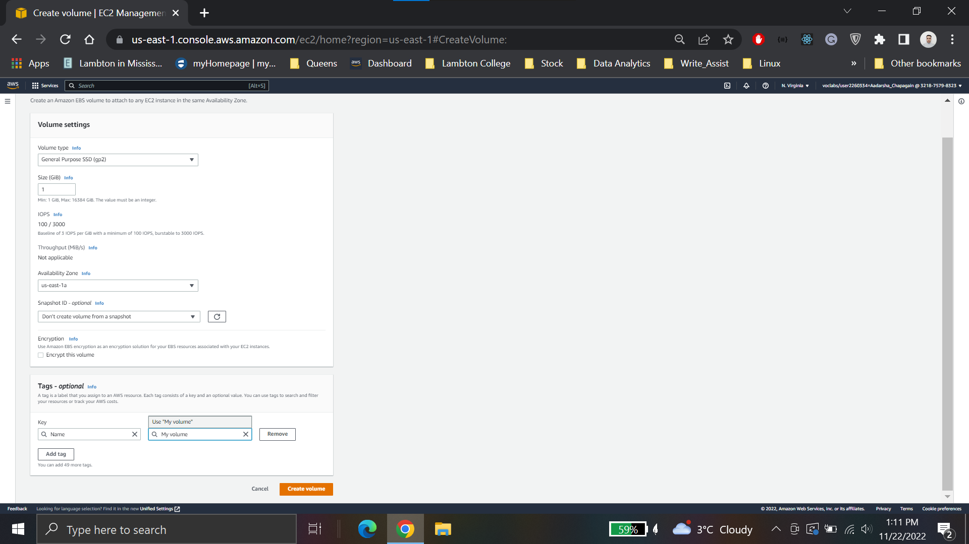

**Attach Volume** 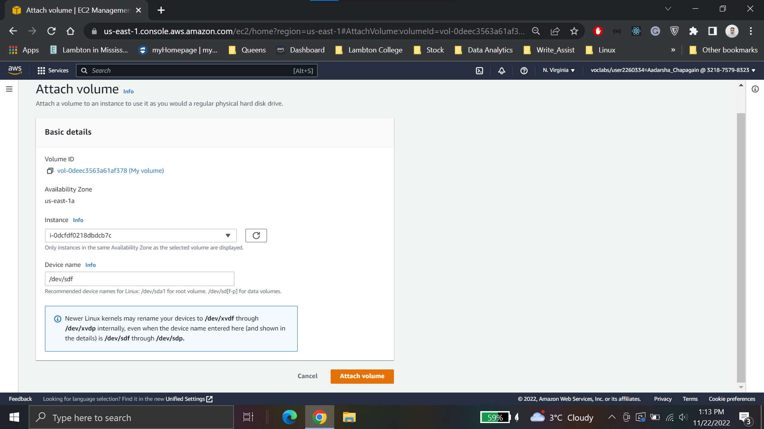

**Login using Putty client**

At first the .ppk was downloaded and using same key in putty ssh connection was established.

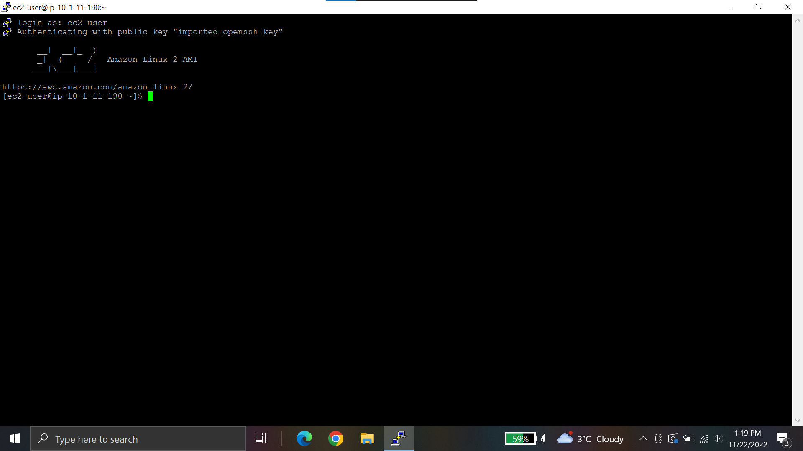

Create an ext3 file system on the new volume

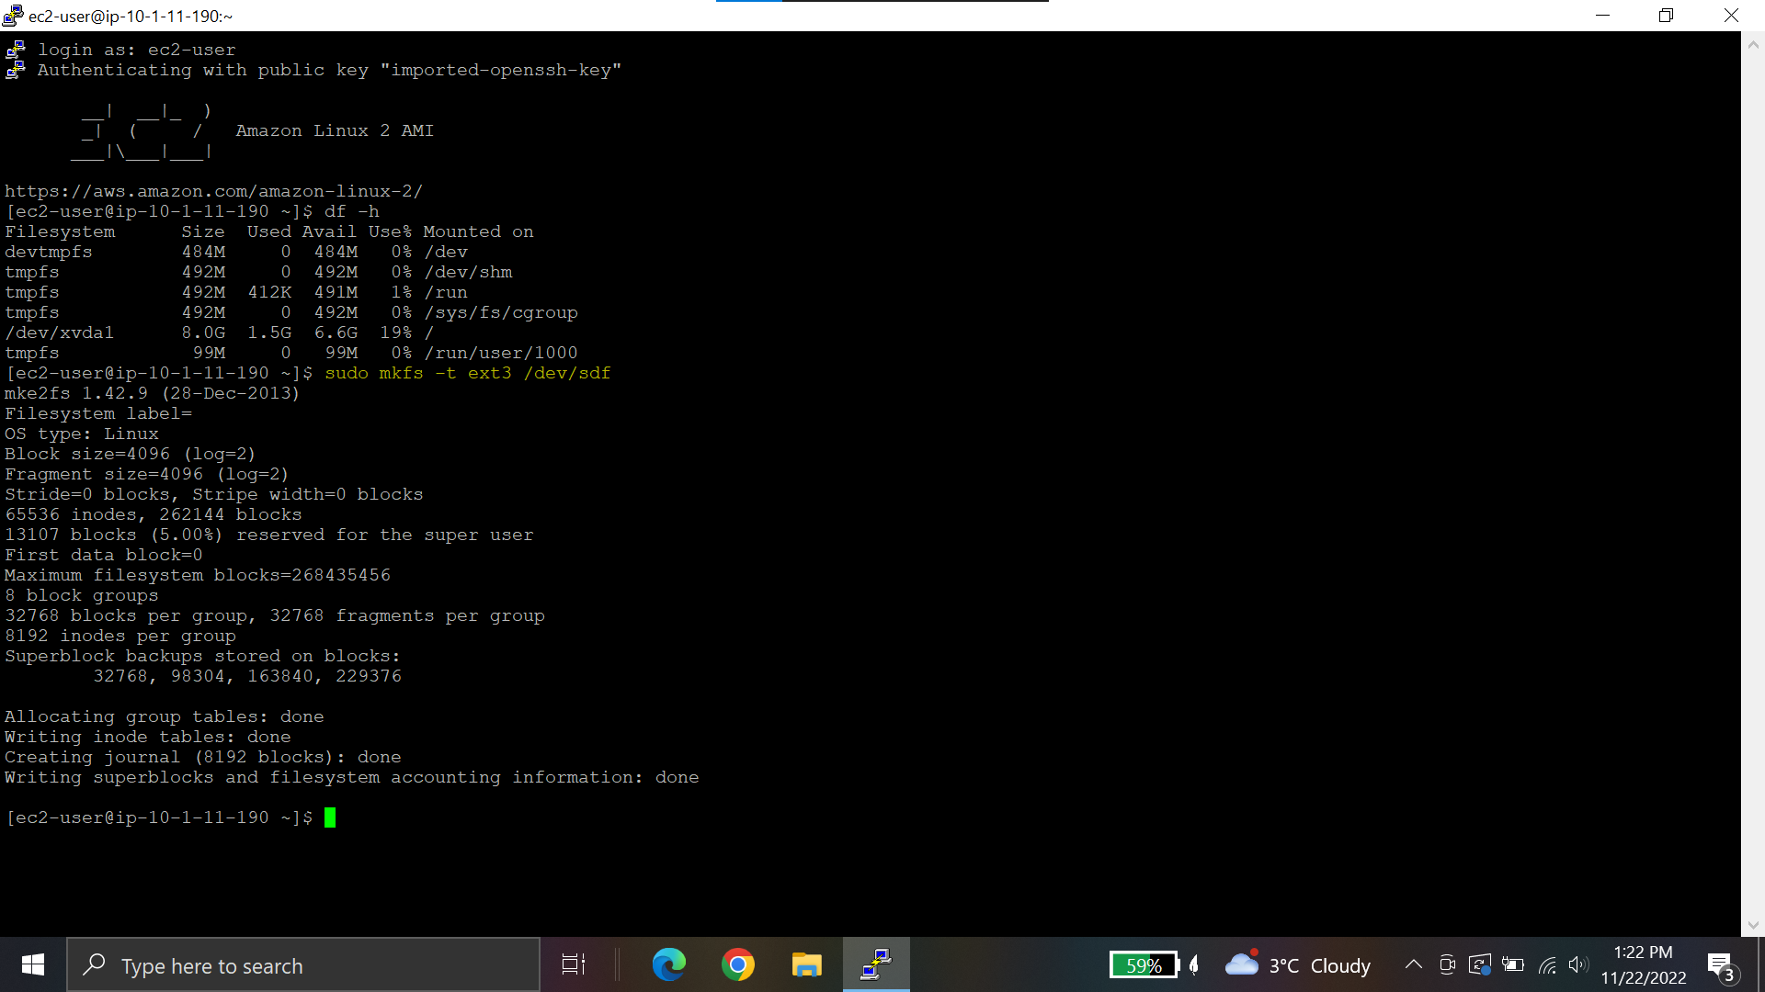

**Create a directory for mounting the new storage volume:**

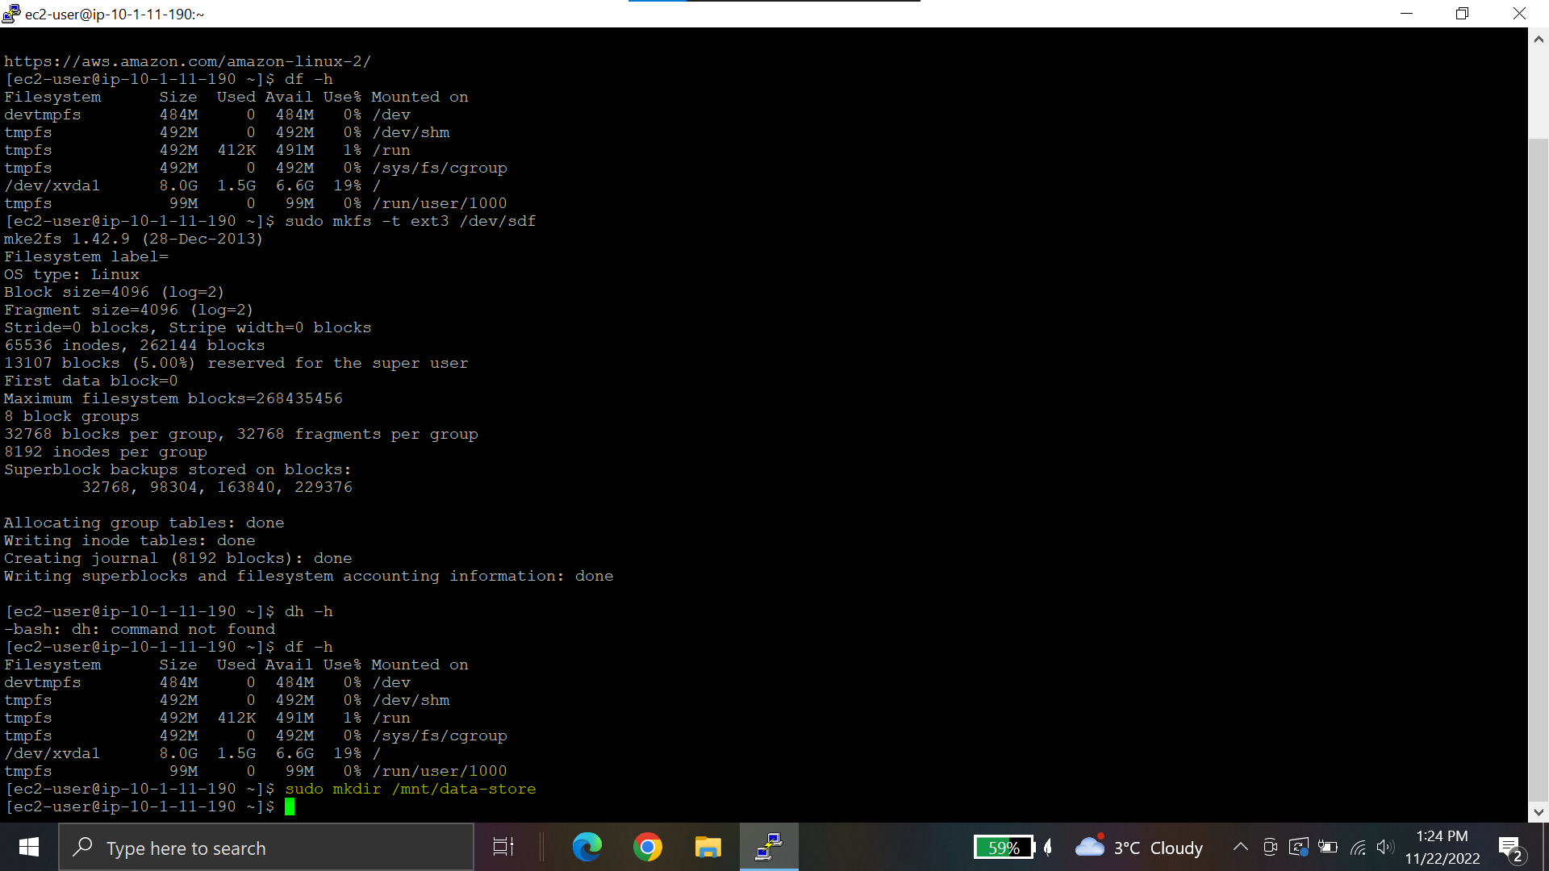

**Mount the new volume:**



**To configure the Linux instance to mount this volume whenever the instance is started, add a line to */etc/fstab*.**



**View the configuration file to see the setting on the last line**



**View the available storage again**

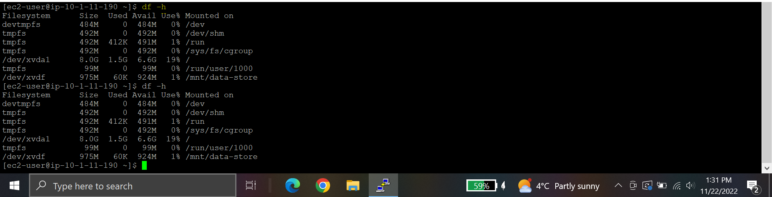

**On mounted volume, create a file and add some text to it.**



**Verify that the text has been written to your volume**



**Create Snapshot**

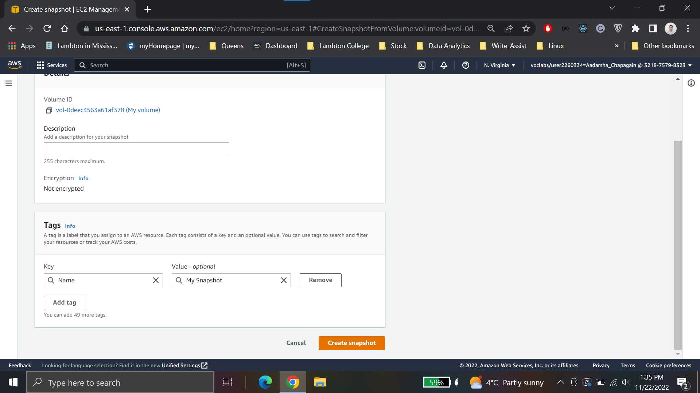

**Snapshot created**

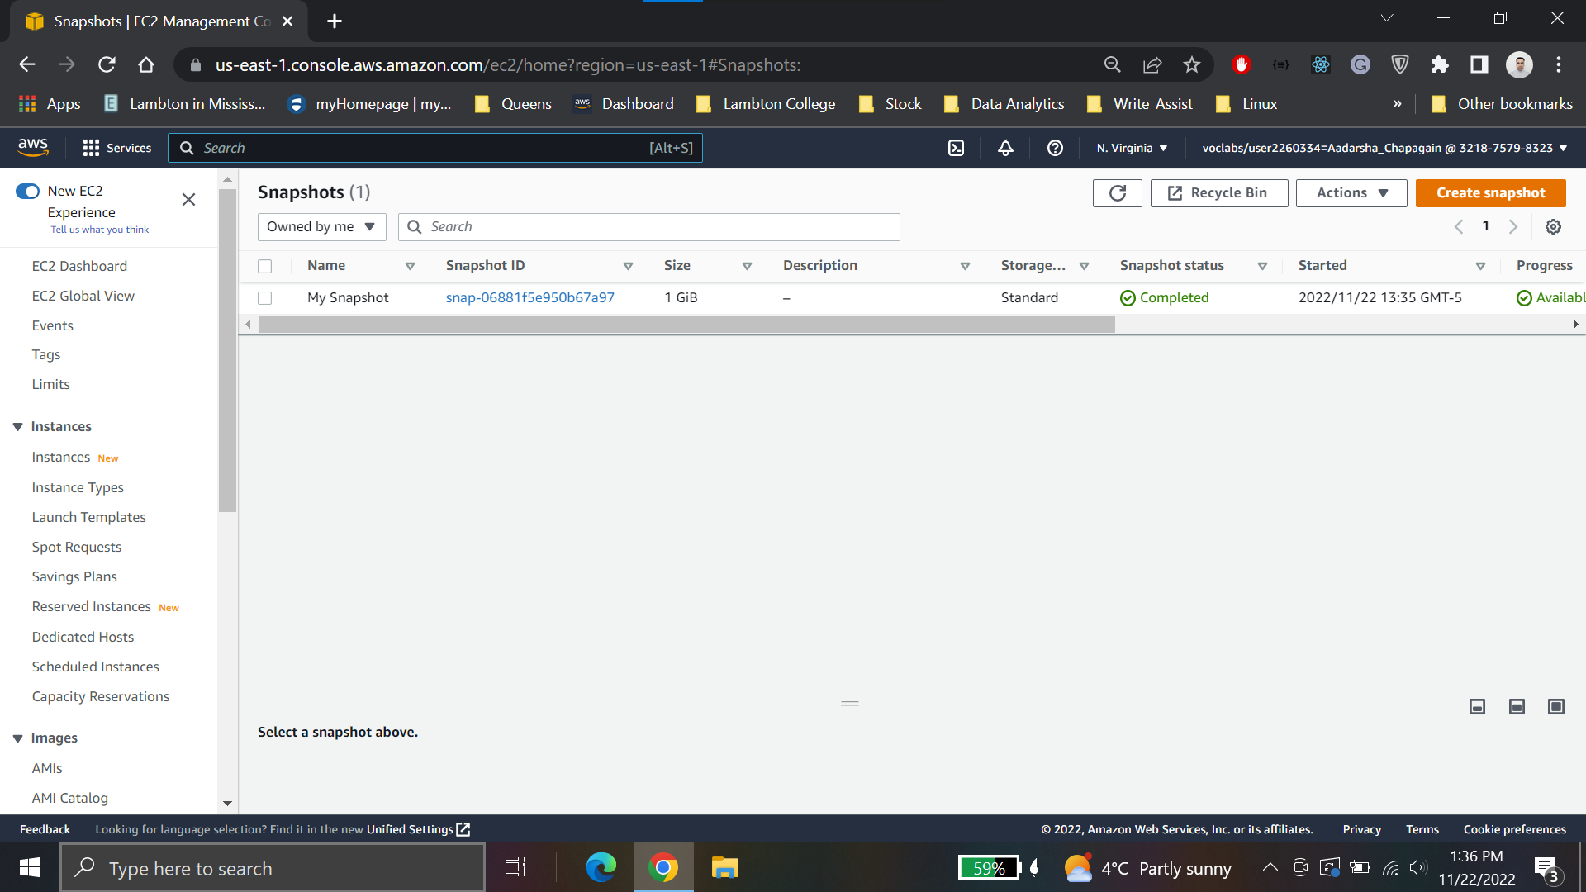

**Delete created file**



**Create volume from stored snapshot**

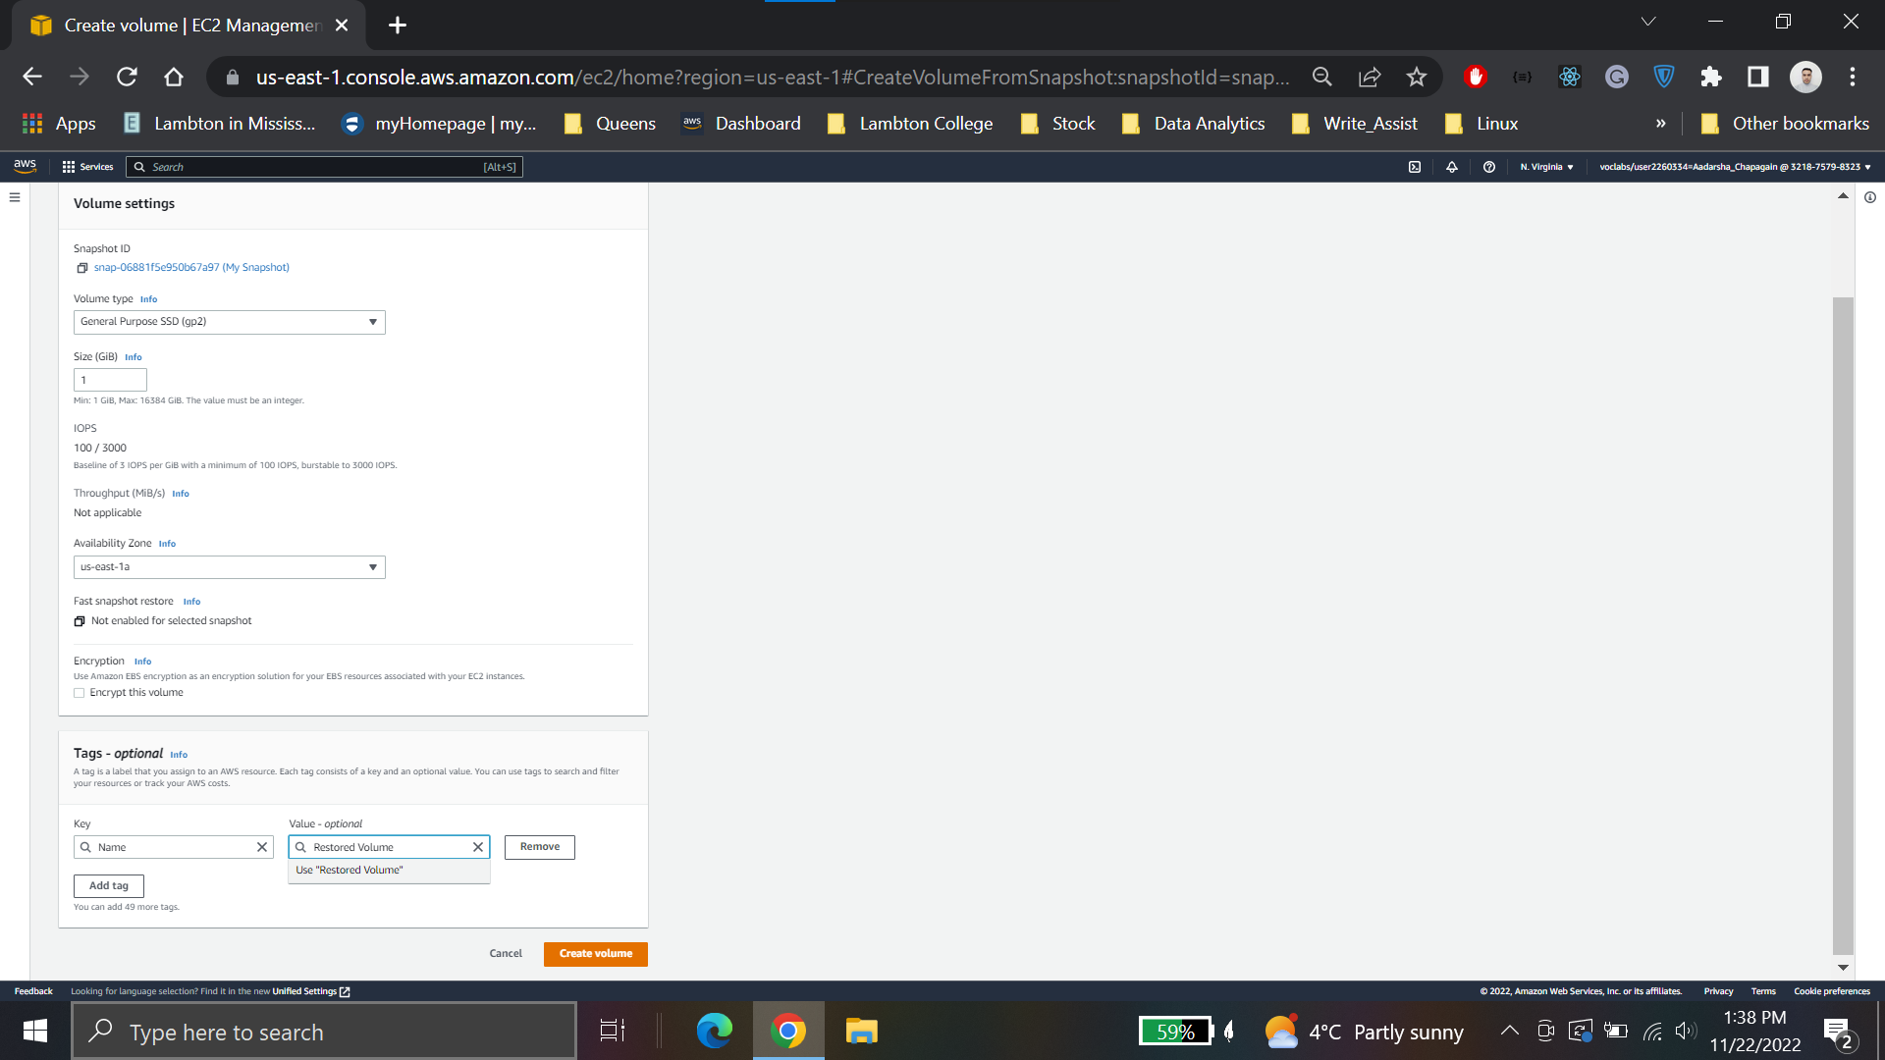

**Attach the volume to instance**

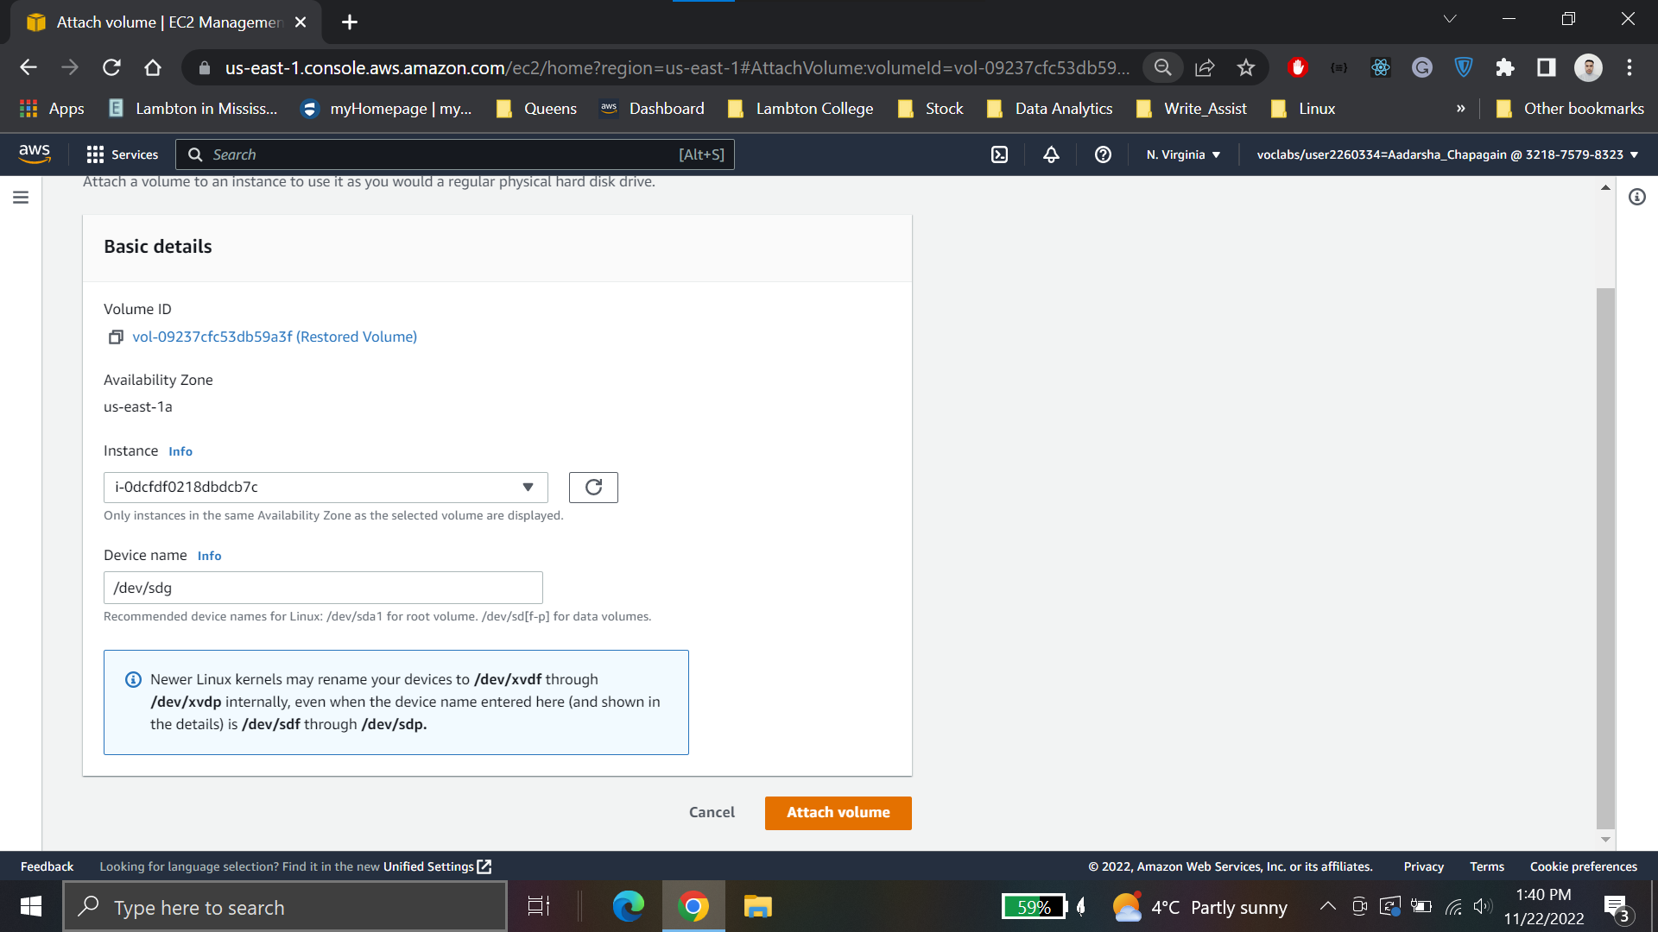

**Create a directory for mounting the new storage volume:**

**sudo mkdir /mnt/data-store2**

**Mount the new volume:**

**sudo mount /dev/sdg /mnt/data-store2**

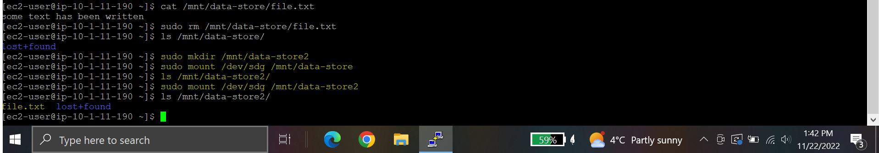

**Conclusions for Lab4**

* Created an Amazon EBS volume
* Attached the volume to an EC2 instance
* Created a file system on the volume
* Added a file to volume
* Created a snapshot of your volume
* Created a new volume from the snapshot
* Attached and mounted the new volume to your EC2 instance
* Verified that the file created earlier was on the newly created volume

**Lab 5: Build Your DB Server and Interact With Your DB Using an App**

**Create a security group**

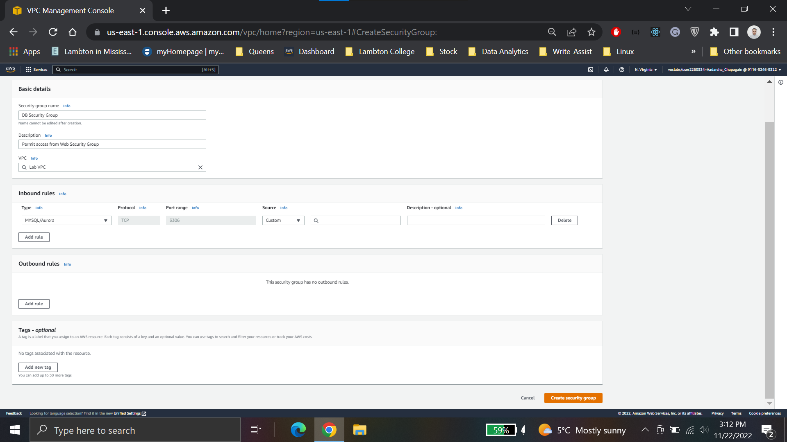

**Create Db Subnet Group**

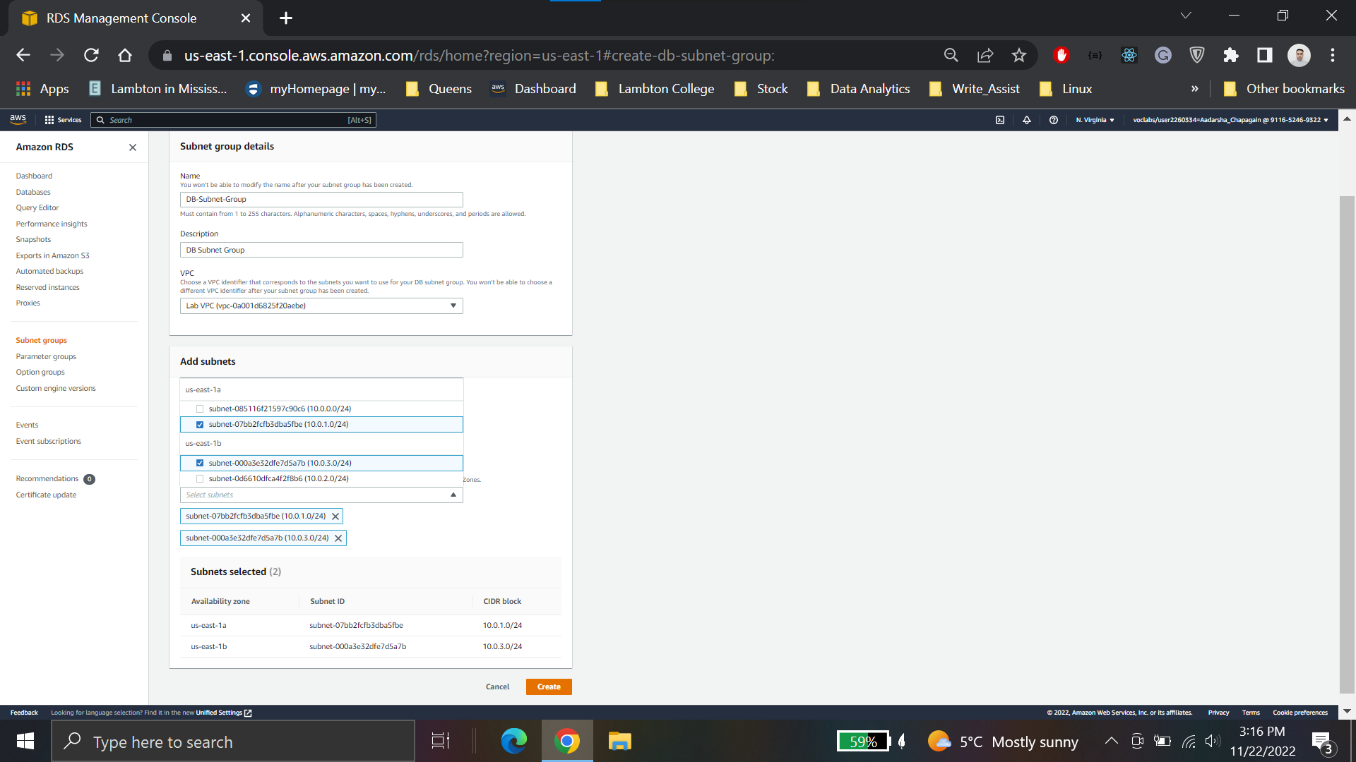

**Create Database**

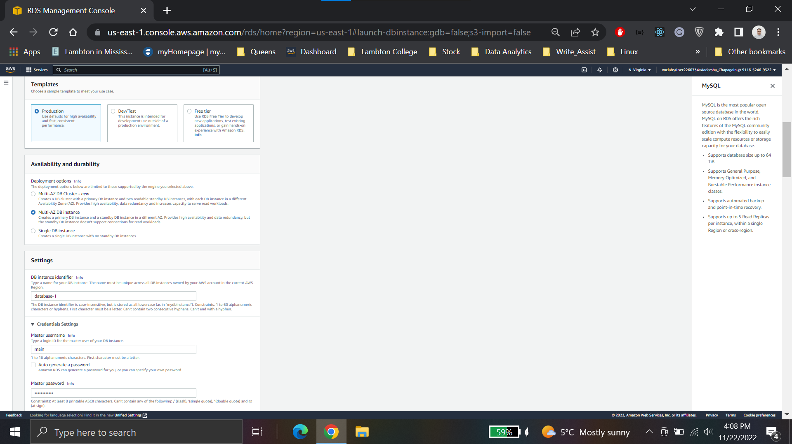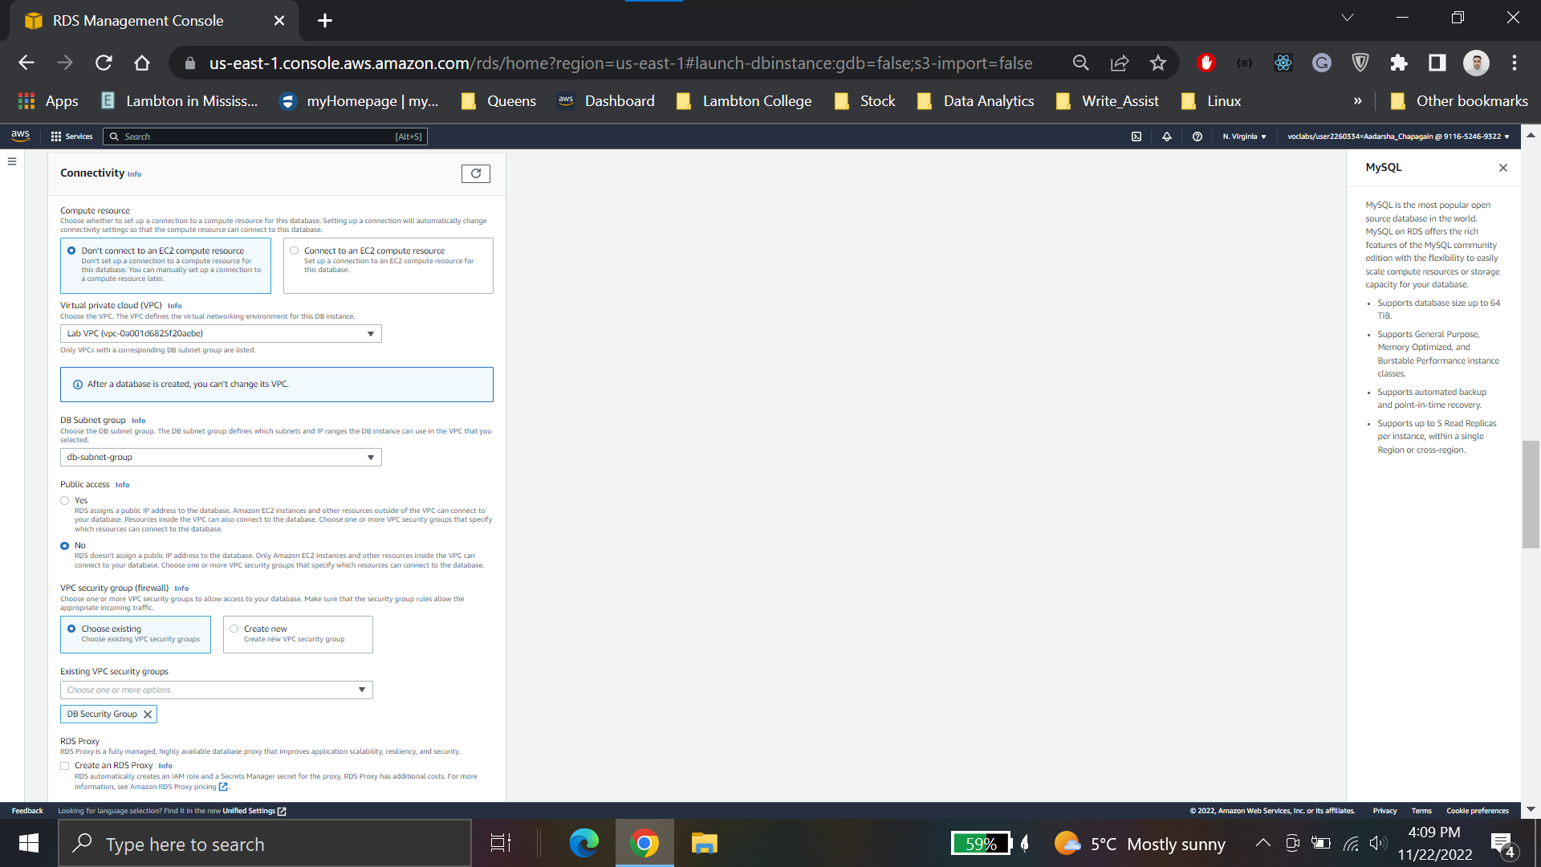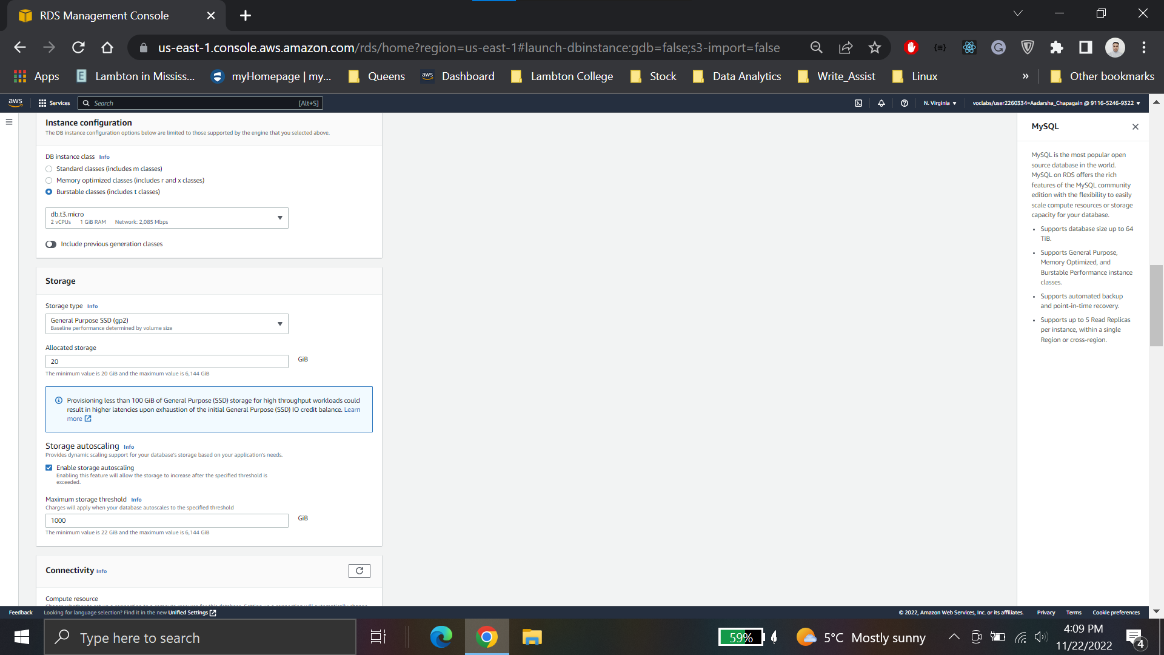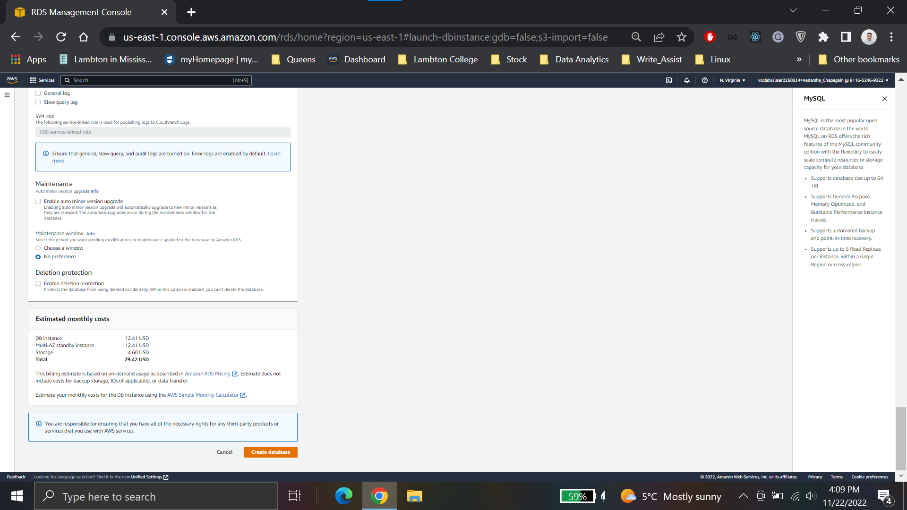

**database-1.c9kgzdoxiquz.us-east-1.rds.amazonaws.com**

**Web server Ip address**

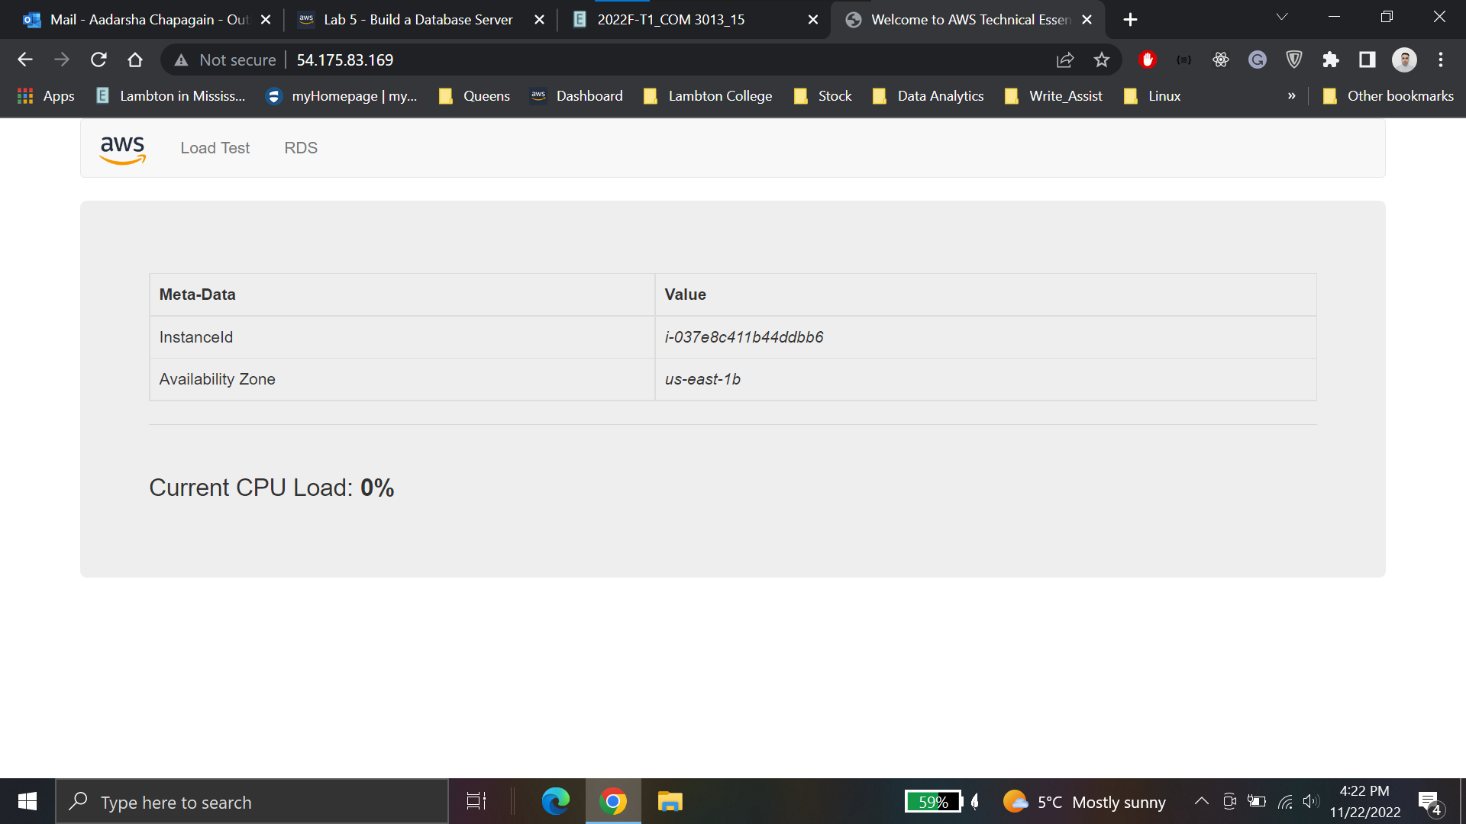

**Web application to interact with database.**

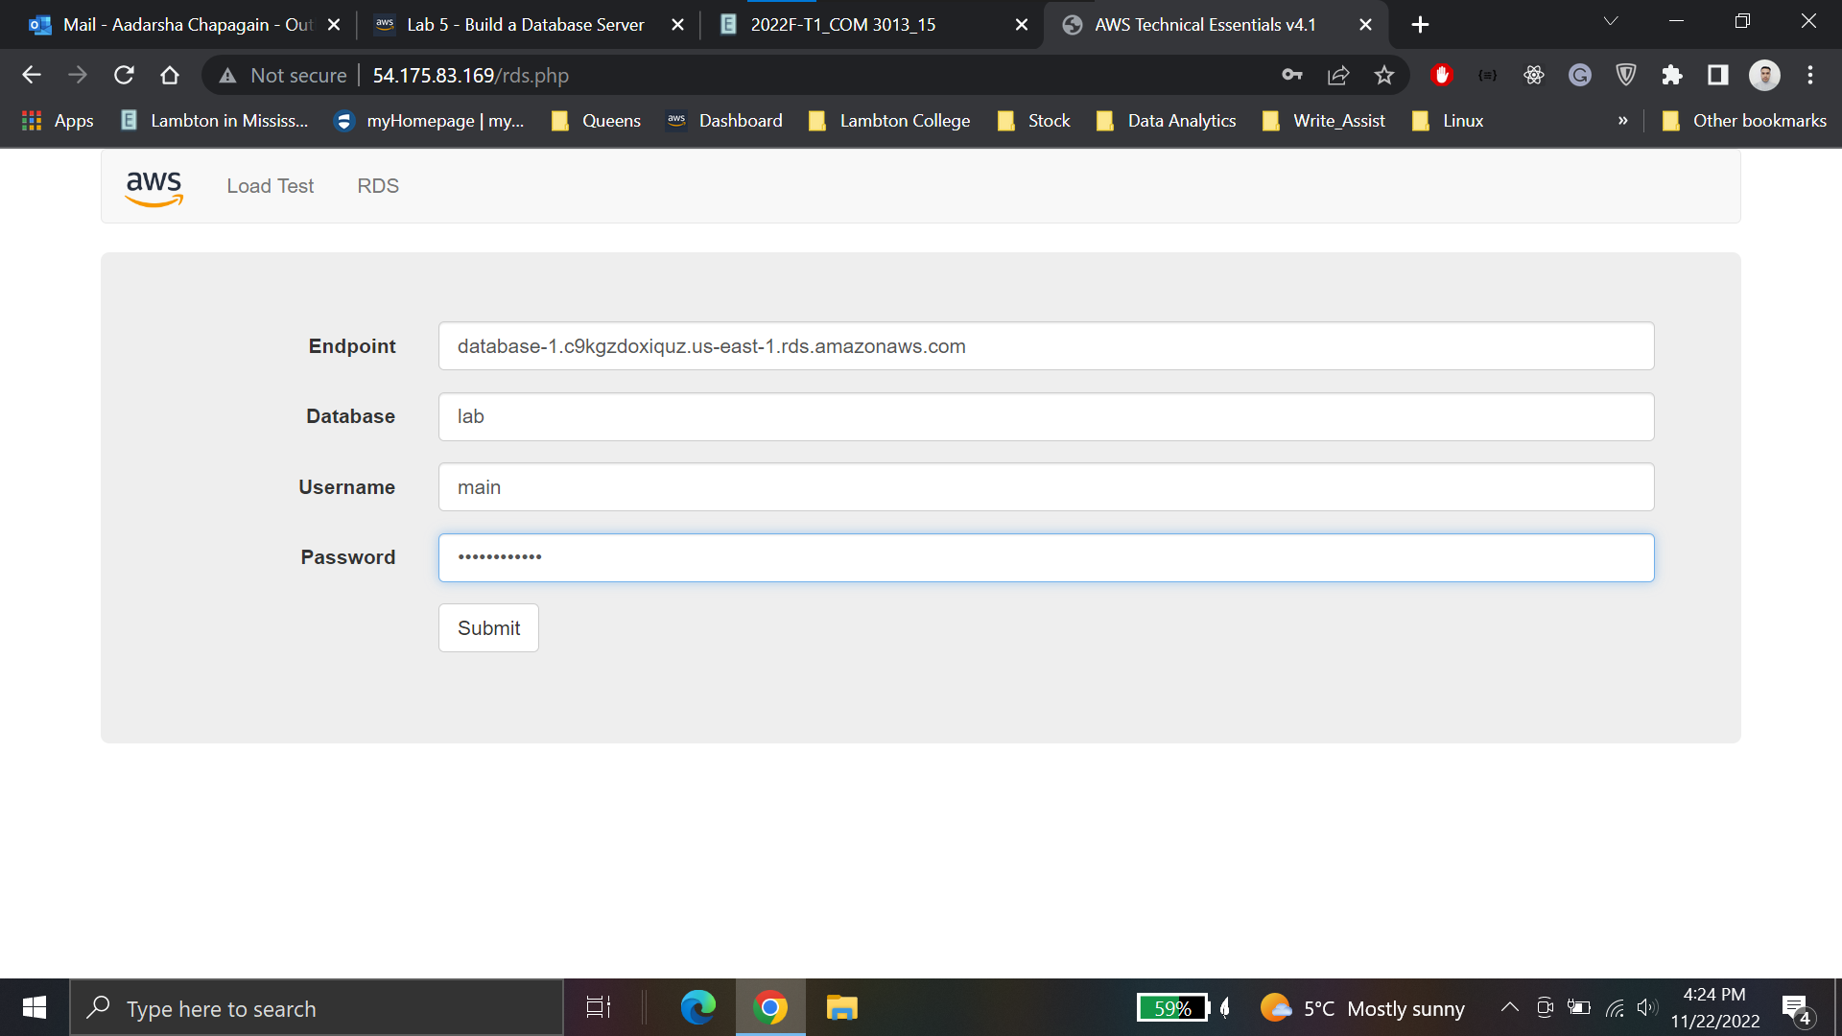

**Created the record to test the connection**

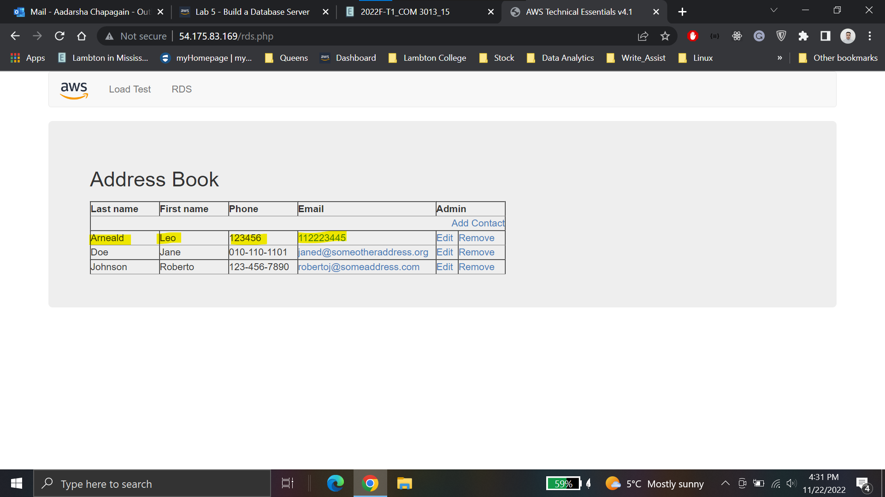

**Lab 5 Conclusion**

* Launched an Amazon RDS DB instance with high availability.
* Configured the DB instance to permit connections from your web server.
* Opened a web application and interact with your database

**Lab 6: Scale and Load Balance Your Architecture**

**Task 1: Create an AMI for Auto Scaling**

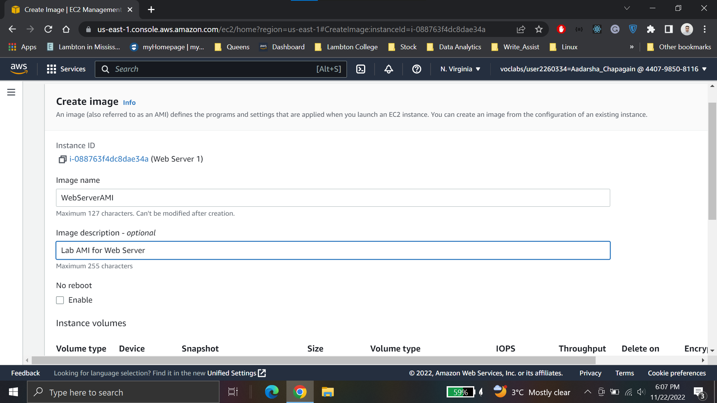

**Task 2: Create a Load Balancer**

**Create a target group**

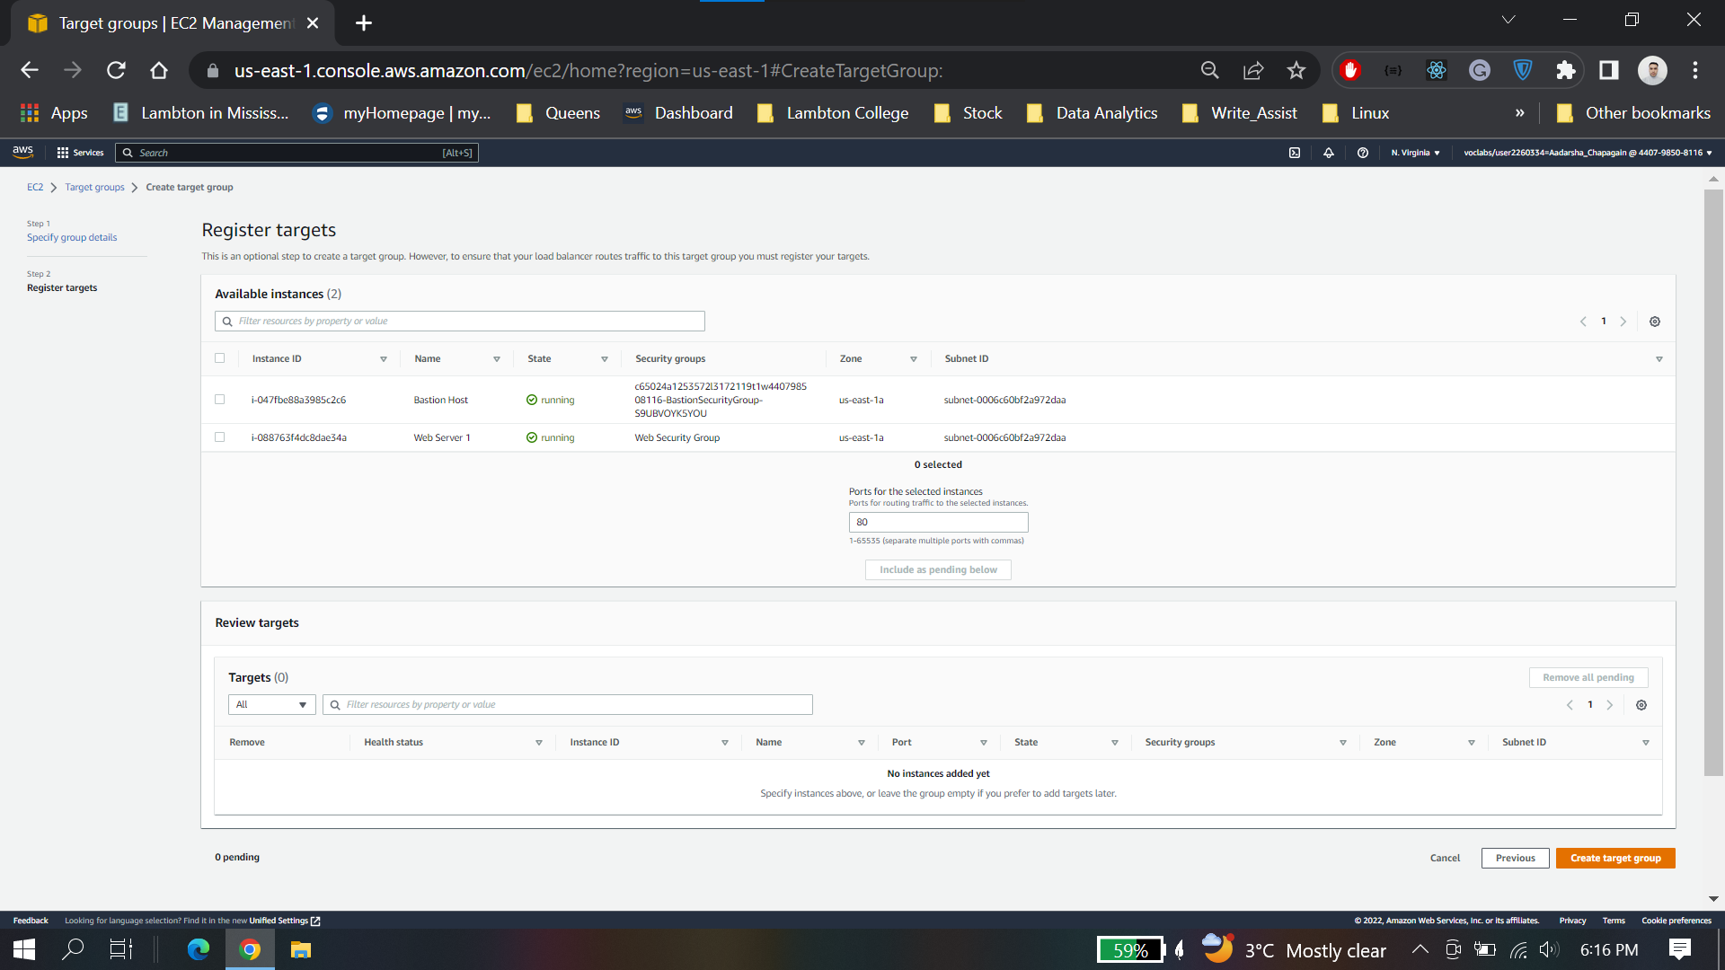

**Create Load Balancer**

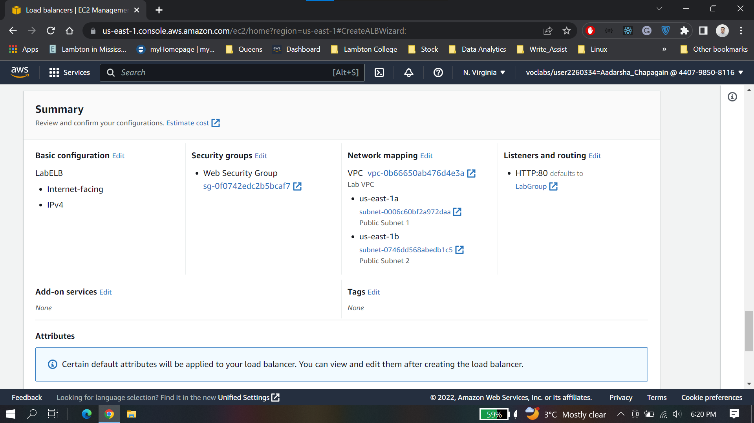

**Task 3: Create a Launch Configuration and an Auto Scaling Group**

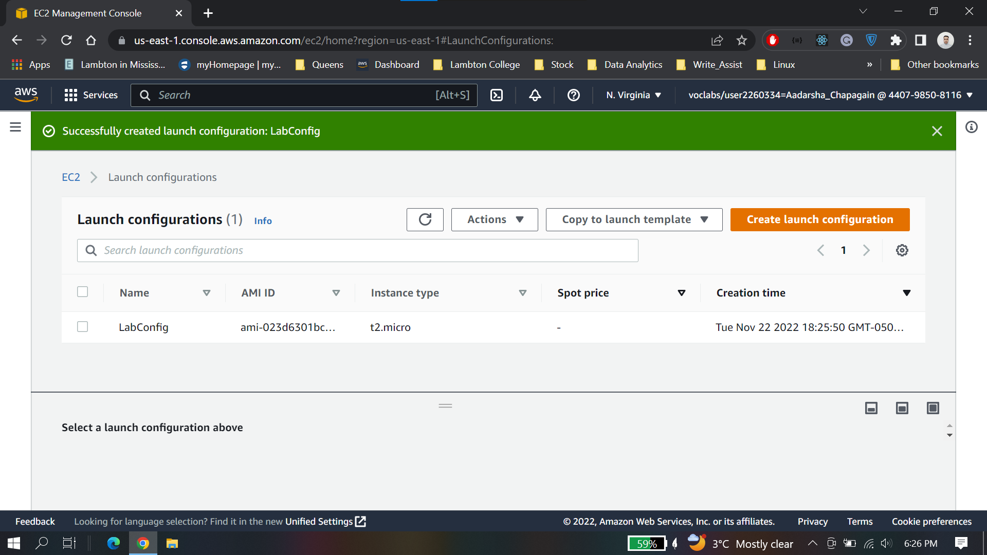

**Creta Auto scaling group**

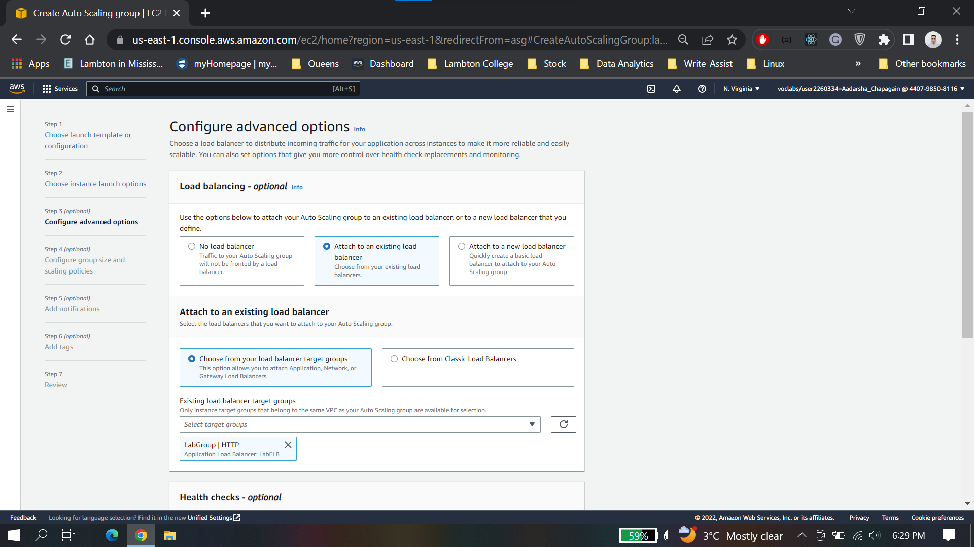

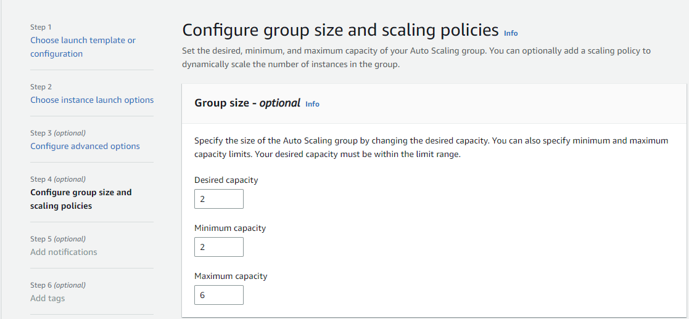

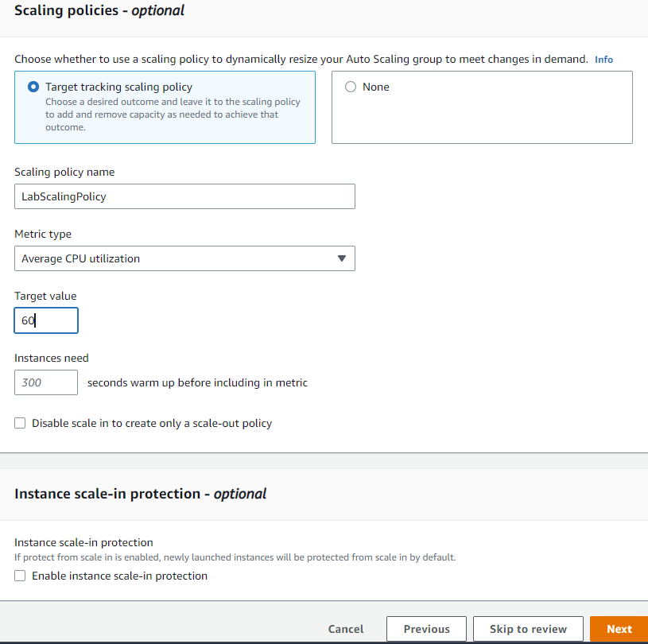

**Review the configurations**

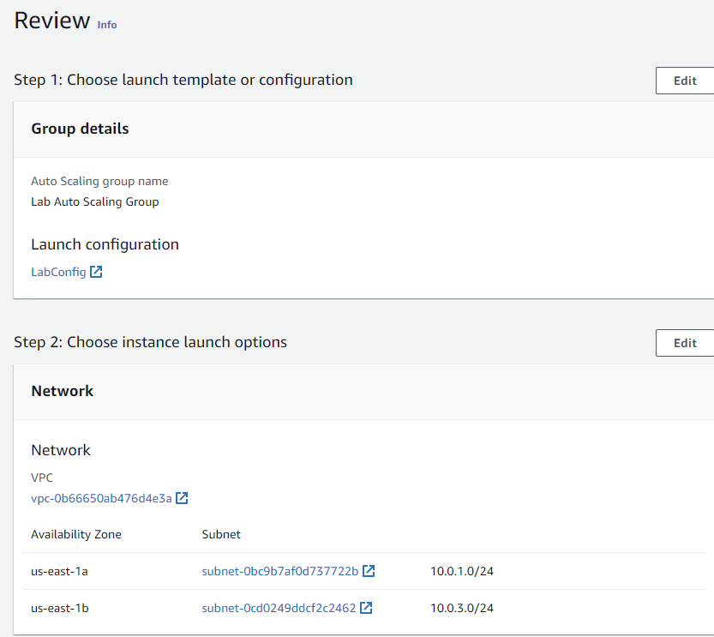

**Newly launched two instances**

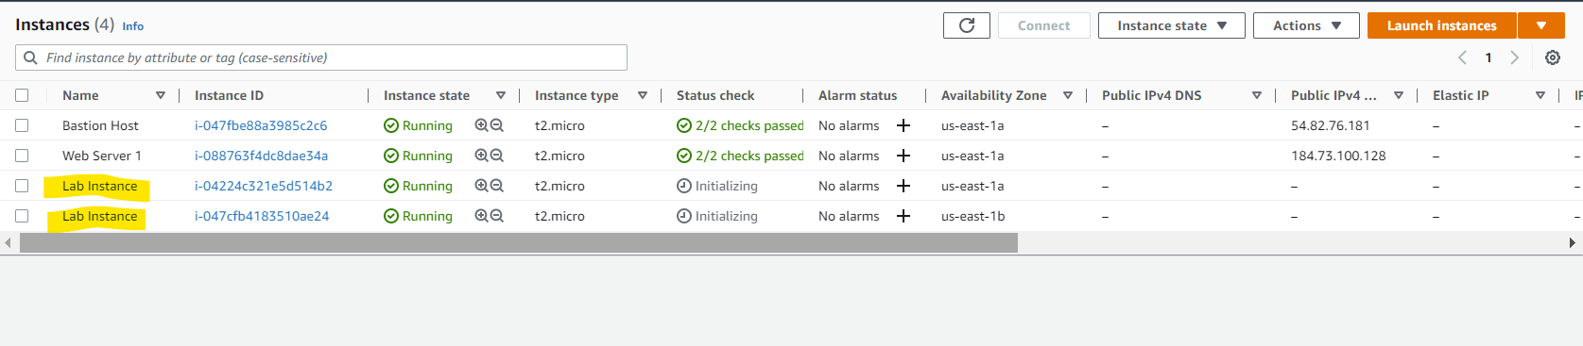

**Task 4: Verify that Load Balancing is Working**

*Healthy* indicates that an instance has passed the Load Balancer's health check. This means that the Load Balancer will send traffic to the instance

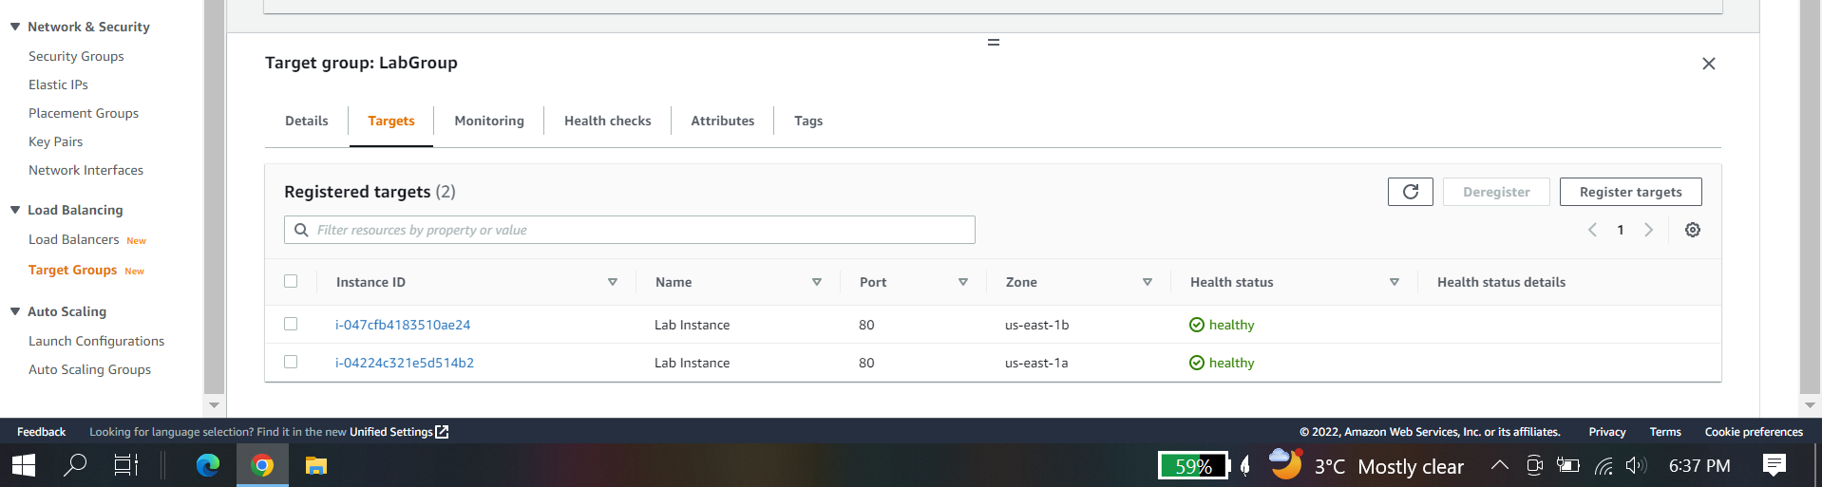

**Test Load balancer**

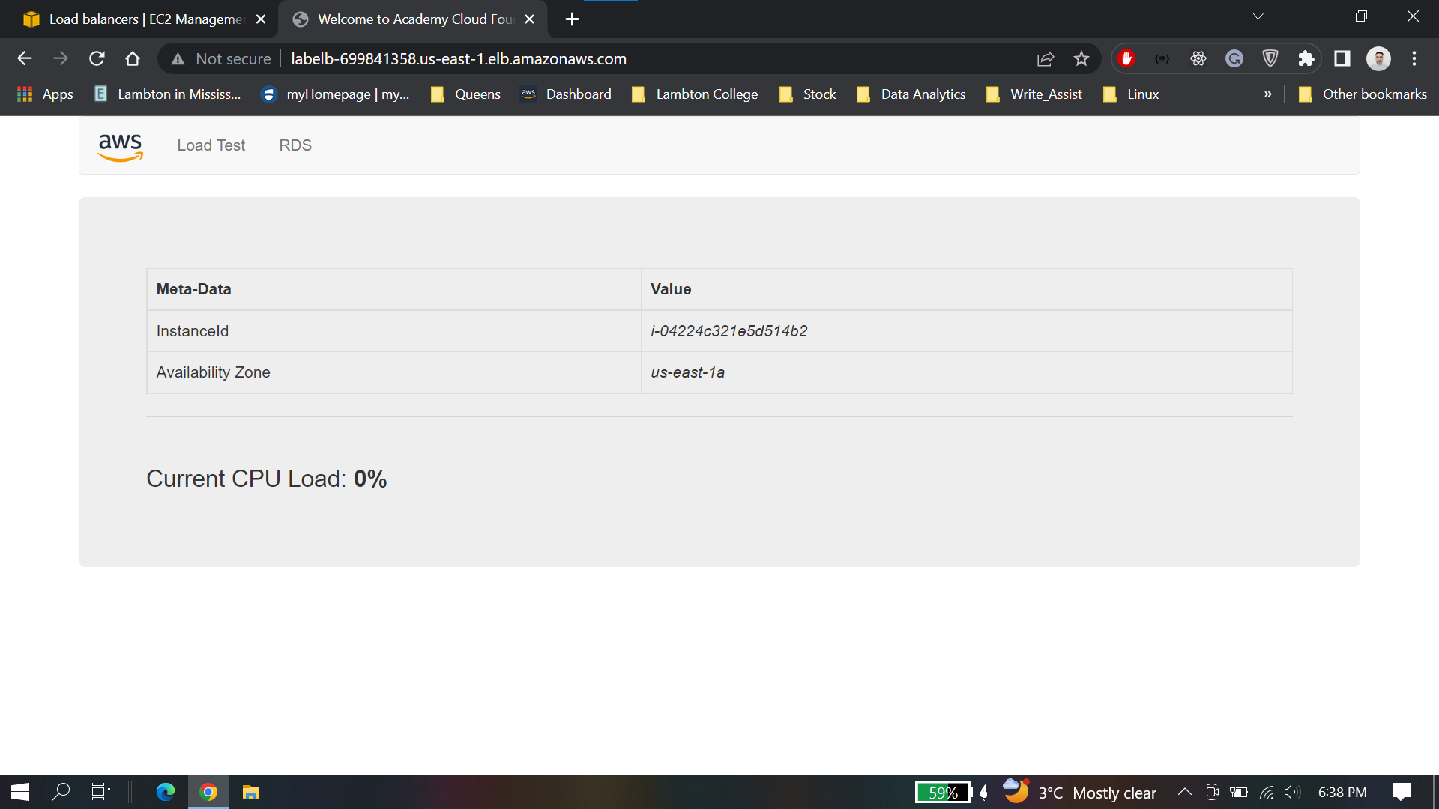

This indicates that the Load Balancer received the request, sent it to one of the EC2 instances, then passed back the result.

**Task 5: Test Auto Scaling**

Two alarms under cloudwatch

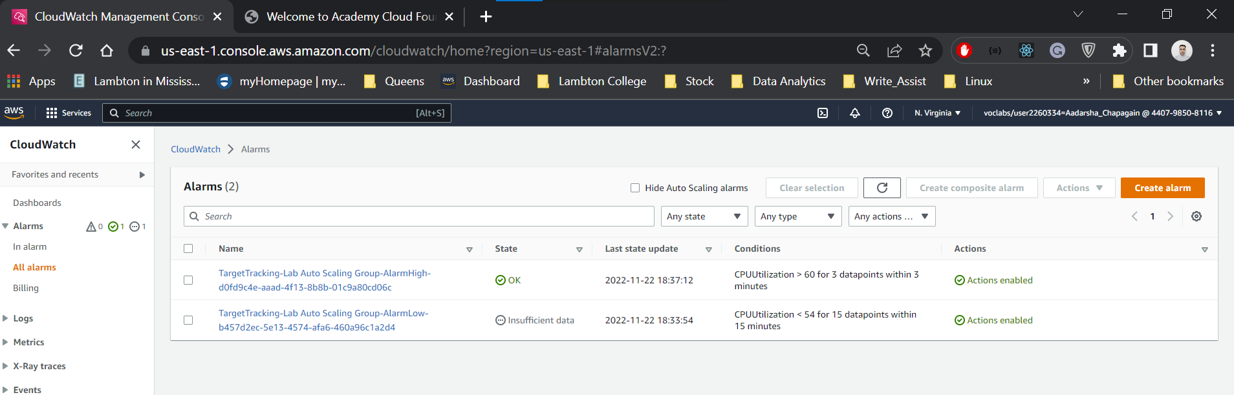

After Performing load test Here Alarm high is in “**In Alarm** “ state 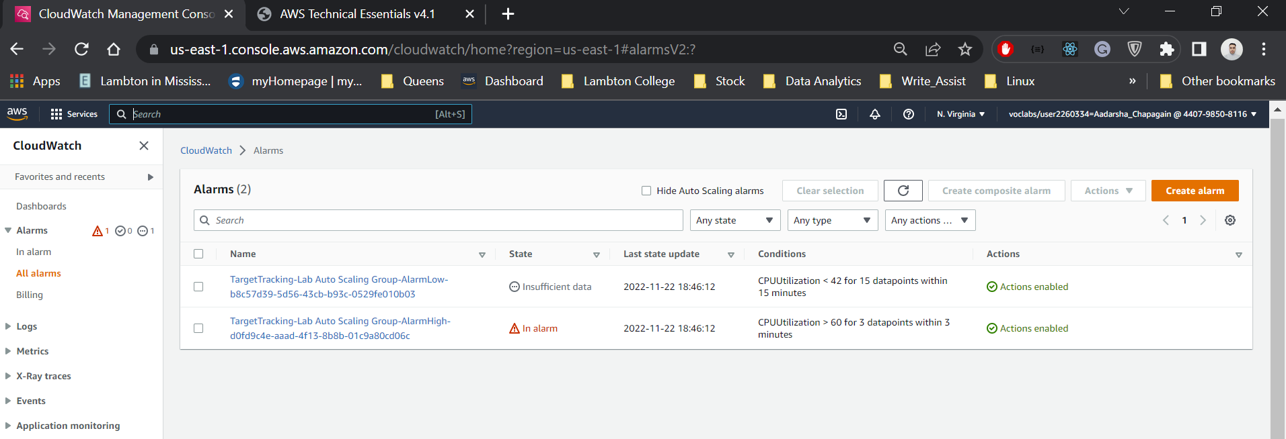

Number of lab instances has increased as well from 2 to 3 instances to handle the load

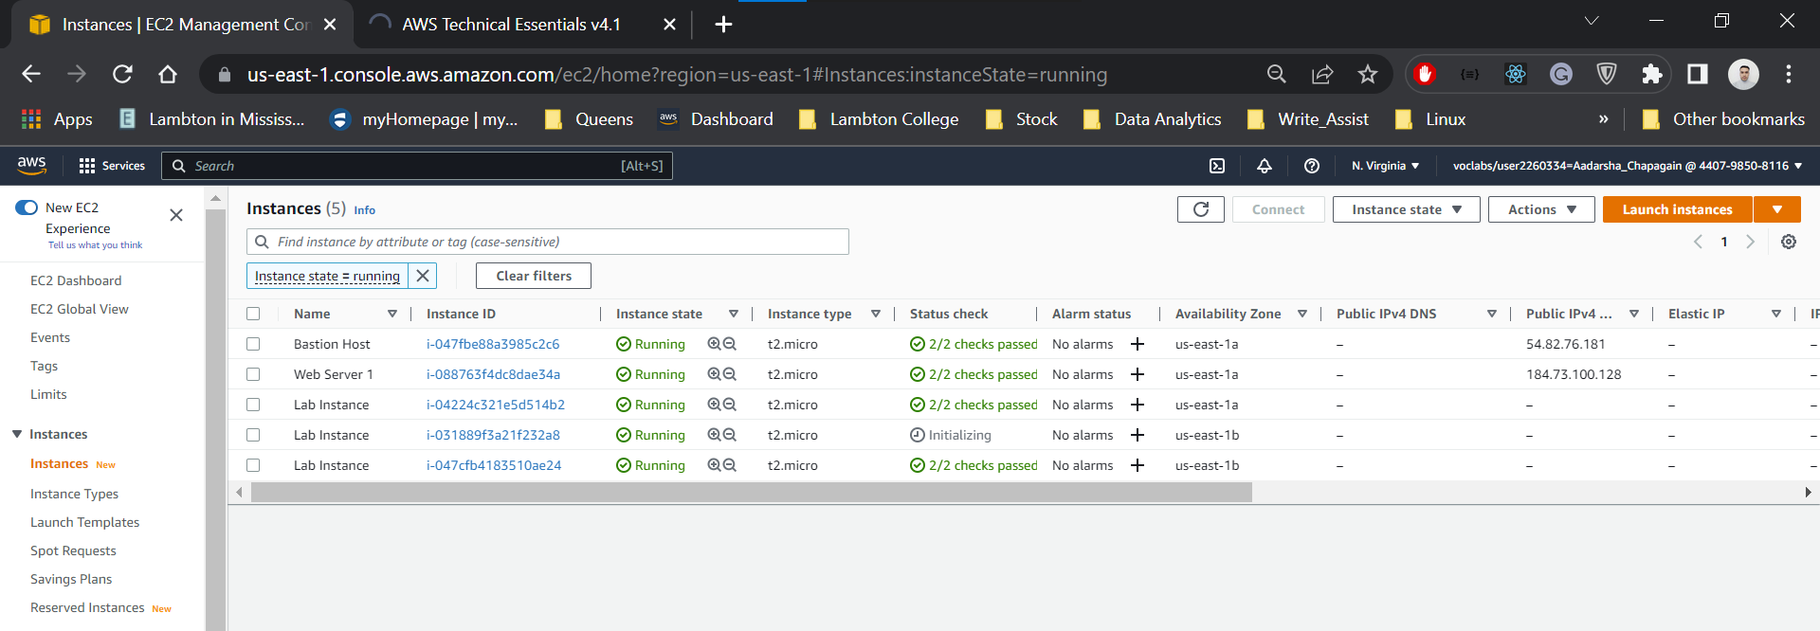

**Lab 6 Conclusion**

* Created an Amazon Machine Image (AMI) from a running instance.
* Created a load balancer.
* Created a launch configuration and an Auto Scaling group.
* Automatically scale new instances within a private subnet
* Created Amazon CloudWatch alarms and monitor performance of your infrastructure.